Statistical Science Workshop 6-7 March 2025 University of Waikato – Tauranga

10-11 March University of Auckland – Leigh Marine Lab

Instructor: David Schneider. Memorial University, St. John’s, Canada

*..statistics must be relevant to making inferences in science and technology.*

*The subject should be renamed statistical science and be focused on the experimental cycle, design-execute-analyse-predict. John Nelder 1999*

What is statistical science?

Statistical science is defined as the application of inferential statistics to the analysis and interpretation of scientific measurements.

Statistical science is not a collection of statistical methods.

Statistical science is not the search for the “best” statistical test.

Statistical science is not the pursuit of p < 0.05

Statistical science is founded on writing a model appropriate to the data generated by a research question.

It uses likelihood ratios to compare statistical models (Fisher 1925).

It uses likelihood ratios to replace the erroneous use of p-values as evidence (Goodman 1993).

It requires a model checking loop (Nelder 1999).

It entails distinguishing three modes of inference, all based on likelihood ratios.

Frequentist Inference from sample to a population via the law of large numbers (Laplace)

Priorist (“Bayesian”) Inference from prior to posterior probability (Laplace 1812, Keynes 1921).

Evidentialist Inference from data to model parameters (Royall 1997, Nelder 1999).

In this workshop you will learn to

Translate a research question into a statistical model

Execute the model and apply the model-checking loop

Calculate a measure of evidence for the research hypothesis (the likelihood ratio)

Calculate a measure of uncertainty on the likelihood ratio (p-value / confidence limit))

Report effect sizes with a measure of uncertainty

Interpret parameter estimates in light of the research question

Goal of the first session Writing the statistical Model

Goal of the second session Executing a GLM in a statistical package

Using the model checking loop

Interpreting computer output

Interpreting the parameter estimates

Statistical Science Workshop Session 1 – Writing the statistical model.

Definitions.

Quantities -- Definition

A well-defined quantity has 5 parts:

a name;

a procedural statement that prescribes the conditions for measurement, or calculations from measurements;

a set of scaled numbers generated by the procedural statement;

units on one of several types of measurement scale;

a symbol that stands for the set of scaled numbers.

Equations are a mixture of variables and parameters (means, slopes, odds ratios)

Equations have units and dimensions.

Equations must be homogeneous with respect to units and dimensions.

The General Linear Model uses parameters $β_{x}$ to relate one or more response variables Y

to one or more explanatory variables XA, XB, *etc*

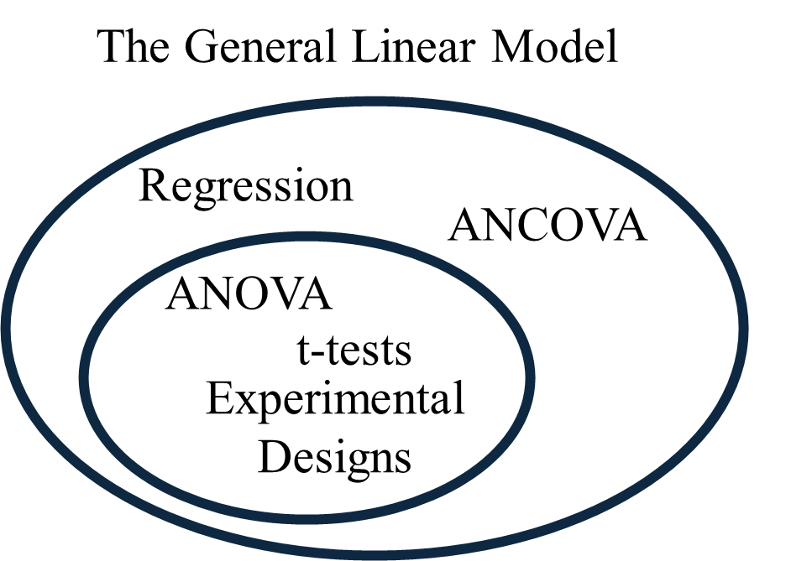

$$Y= β_{o}+β_{XA}{XA}_{1}+β_{XB}{XB}_{1}+error$$

$β_{o}$ = $ΣY/n$ = mean(Y) = $\overline{Y}$

Regression: $β_{XA}$ = slope estimate (change in Y/change in XA)

ANOVA: $β_{XA}$ = contrasts: $β_{o}-β_{XA_1}$, $β_{o}-β_{XA_2}$ , *etc*

Statistical Science Workshop Session 1 – How to write a statistical model

Define Variables

Distinguish response (“dependent”) variables from explanatory (“independent”) variables

Assign symbols to all variables

Notational conventions

Nominal scale variable ALL UPPER CASE

Ratio scale variables Begin with upper case.

*β* for fixed effect coefficients (slopes and contrasts)

*µ* for random effect parameters

Write the model by hand: Response ~ X1 + X2 …. + error

Rewrite the model in ANOVA table format

Calculate the df.

Complete the second column of the ANOVA table

First example (Regression)

Example 9.3.1 from Snedecor and Cochran (1989).

Does the phosphorus content of corn increase when organic soil phosphorus is increased ?

*Pcorn* and *Psoil* are both ratio scale variables. 9 measurements of *Pcorn*, matched with 9 of *Psoil*.

Quantity of interest is the phosphorus content of corn (*Pcorn* in ppm), in relation to the phosphorus levels in samples of soils with experimentally fixed levels of phosphorus (*Psoil* in ppm).

What is the response variable? ____________________ Symbol ___________

What is the explanatory variable? ____________________ Symbol ___________

How many parameters describe the relation of response to explanatory? _______________

Sketch graph of response vs explanatory

One parameter for each regression line

Using symbols, write the model

Model ________ = ________________________ + _________

error

|  |  |
| --- | --- |
| Source | df |
|  |  |
| error | 7 |
| total |  |

df ________= __________________________ + _____

n-1 number of parameters error

<http://www.mun.ca/biology/schneider/b4605/LNotes/Pt3/Ch9_1.pdf>

Statistical Science Workshop Session 1 – Writing the statistical model.

First example

Example 9.3.1 from Snedecor and Cochran (1989).

Does the phosphorus content of corn increase when organic soil phosphorus is increased ?

*Pcorn* and *Psoil* are both ratio scale variables. 9 measurements of *Pcorn*, matched with 9 of *Psoil*.

Phosphorus in corn *Pcorn* Response variable, ratio scale

Phosphorus in soil *PSoil* Ratio scale explanatory variable

Write the model *Pcorn = βo + βPsoil Psoil + εNormal*

Calculate df (9) = 1 + 1) + 7

|  |  |
| --- | --- |
| Source | df |
| *Psoil* | 1 |
| error | 7 |
| total | 8 |

df total = ntot -1 TRT df = number of categories – 1

Fill out first 2 columns of ANOVA table from model

Statistical Science Workshop Session 1 – Writing the statistical model.

Second example

Does inversion heterozygosity (HZYG) change with elevation above sea level (*Hsl*) in *Drosophila* *persimilis*). Data are from Dobzhansky (1948) as reported in Brussard (1984).

|  |  |
| --- | --- |
| Source | df |
|  |  |
|  | 5 |
|  |  |

One measurement of HZYG at each of 7 different elevations.

Response variable with symbol ______________________ ______

Explanatory variable with symbol ___________________ ______

Model _________________________________________

df __________________________________________

Statistical Science Workshop Session 1 – Writing the statistical model.

Third example. (ANOVA)

Pea section growth data, from Box 9.4 in Sokal and Rohlf (1995).

Does length depend on treatment (control versus 4 different sugars with auxin present) ?

10 measurements of length of pea section in each treatment group

What is the response variable? _______________ Assign a symbol ___________

What is the explanatory variable? _______________ Assign a symbol ___________

Is the explanatory variable on a nominal, ordinal, interval, or ratio scale? ___________

How many parameters describe the relation of response to explanatory? ___________

Grand mean +

Sketch graph of response vs explanatory

One parameter for each contrast

n = sample size

|  |  |
| --- | --- |
| Source | df |
|  |  |
| error | 45 |
| total |  |

Using symbols, write the model

Model ________ = ________________________ + _________

error

df ________= __________________________ + _____

n-1 number of parameters error

Statistical Science Workshop Session 1 – Writing the statistical model.

Third example

Pea section growth data, from Box 9.4 in Sokal and Rohlf (1995).

Does length depend on treatment (control versus 4 different sugars with auxin present) ?

10 measurements of length of pea section in each treatment group

Length *Len* Response variable, ratio scale

Treatment *TRT* Categorical explanatory variable

Write the model *Len = βo + βTrt TRT + εNormal*

Calculate df (10*5) = 1 + (5-1) + 45

|  |  |
| --- | --- |
| Source | df |
| *TRT* |  |
| error |  |
| total | 49 |

df total = ntot -1 TRT df = number of categories – 1

Fill out first 2 columns of ANOVA table from model

<http://www.mun.ca/biology/schneider/b4605/LNotes/Pt3/Ch10_3.pdf>

Statistical Science Workshop Session 1 – Writing the statistical model.

Fourth example (ANCOVA)

Does change in inversion heterozygosity (HZYG) with elevation above sea level (Hsl) in *Drosophila* *pseudoobscura*) differ from that of *D. persimilis* at the same locations?

Data are from Dobzhansky (1948) as reported in Brussard (1984).

|  |  |
| --- | --- |
| Source | df |
|  |  |
|  |  |
|  |  |
|  | 10 |
|  |  |

One measurement of HZYG at each of 7 different elevations in two species.

Response variable with symbol ____________________________ _______

Explanatory variable V1 with symbol _____________________ _______

Second explanatory variable V2 with symbol ________________ _______

Interactive effect (compares slopes) V1 x V2 _____________ _______

Model ____________________________________________________

df ____________________________________________________

Statistical Science Workshop Session 1 – Writing the statistical model.

Review of Session 1

The learning goal was to write a statistical modal to address a research question.

This replaces the search for the “right test.”

Once learned, we can write a model for which we do not know the name.

For example, students can execute a latin square design, even though they do not know the name of the test.

Along the way, we learned several important concepts:

Explanatory vs response variables

Parameters relate response to explanatory variables.

Categorical (ANOVA) vs ratio scale (regression) variables.

Use of contrasts to compare means of a categorical variable.

Partitioning the degrees of freedom in an ANOVA table

We set up the model for four examples – two regressions, an ANOVA, and an ANCOVA.

In Session 2 we will learn to use a generic recipe for statistical analysis, based on writing the model.

The recipe will be demonstrated for regression, using the first example, phosphorus content in corn.

You will apply this to the second example, fly heterozygosity, another example of regression.

The recipe will then be demonstrated for ANOVA, using the third example, the pea section data.

You will then apply this to a new example, oat yields for treated and untreated plants.

As time permits, the fourth example (ANCOVA) will be demonstrated while you carry it out in the statistical package.

Session 5 – GLMM. The General Linear Mixed Model (Experimental Design)

Fixed versus random factors.

In all four examples in Session 1 the explanatory variables were fixed.

1. Does the phosphorus content of corn increase when organic soil phosphorus is increased ?

Based on nutrient requirements, we expect a positive relation. We wish to estimate the relation.

2. Does inversion heterozygosity (HZYG) change with elevation above sea level (Hsl) in *Drosophila* *persimilis*)?

*Hsl* is a fixed effect because we expect a decrease in *Hzyg* in harsher environments at higher elevations.

with elevation (altitude above sea level)

3. Does length depend on treatment (control versus 4 different sugars with auxin present) ?

Treatment levels are fixed by design. We are inferring only to the levels in the experiment

*TRT* is a fixed effect because we are interested in the contrast of 4 means, relative to the control.

*βTRT* is a set of unknown fixed effect contrasts.

4. Does change in inversion heterozygosity (HZYG) with elevation above sea level (Hsl) differ in 2 species ?

The explanatory variable is fixed for several reasons.

First of all, we expect a decrease.

Second the study has a repeatable protocol. It can be repeated at the same elevations.

The categorical variable is fixed because we are only inferring to these two species.

We are not inferring to all species of fruit fly, based on a sample of only two species.

Inferring to all species (taking species as random) is too much of a stretch.